PRACTICE TASK CLASS -11
- netstat command
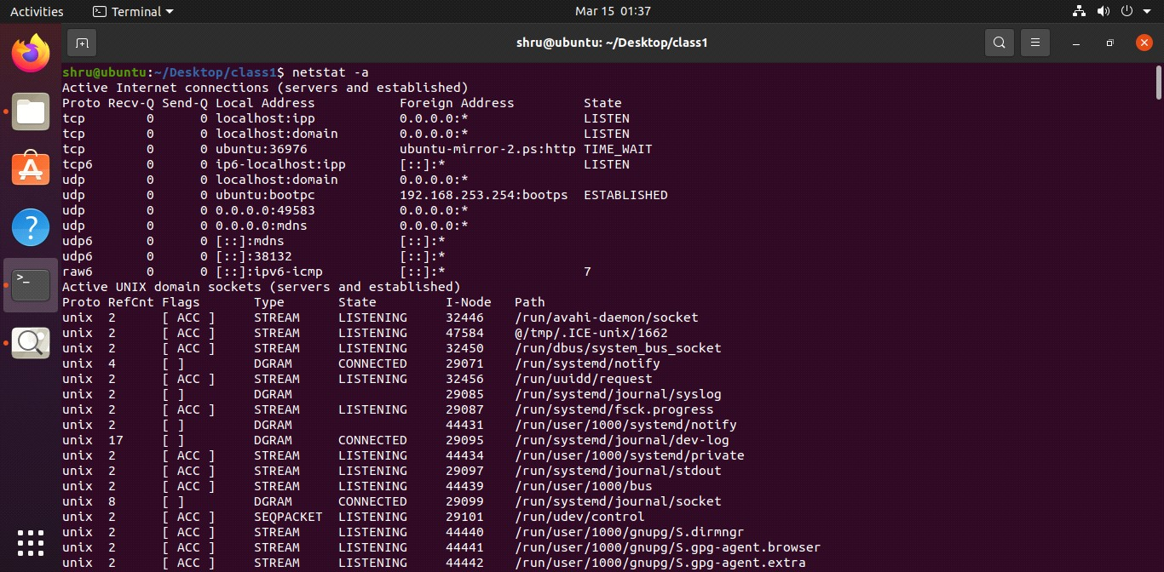
FIND COMMAND

- to find all empty and non empty files, dir's and links
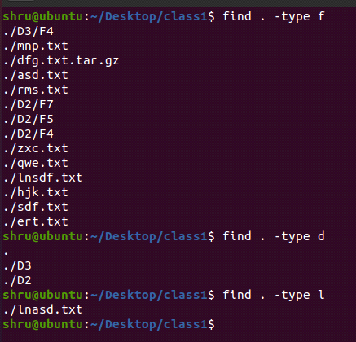

- to find all empty files, dir's and links
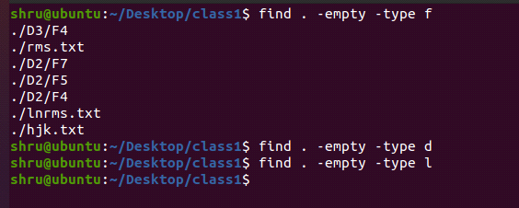
- to find all non empty files, dir's and links
